**StreamDeck Stream/Recording Status Indicator StreamerBot Extension**

**Created by Vengey**

**[** [**https://twitter.com/ItsVengey**](https://twitter.com/ItsVengey) **|** [**https://www.twitch.tv/itsvengey**](https://www.twitch.tv/itsvengey) **|** [**https://vengey.carrd.co/**](https://vengey.carrd.co/) **]**

**How to Import into StreamerBot…**

**STEP 1: *Copy this LONG string***



**STEP 2**: ***Click Import in Streamerbot***

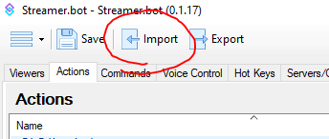

**STEP 3**: ***Paste the code into “Import String”, an action will show up, then hit “Import”***

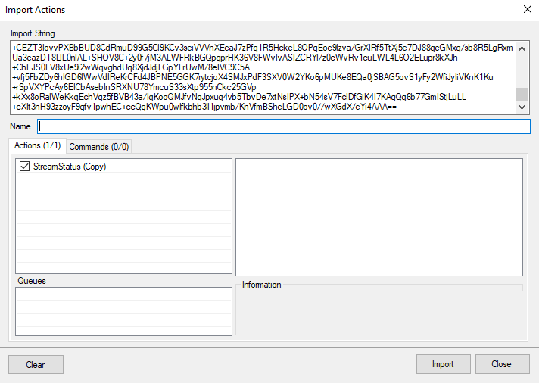

**STEP 4**: ***Go to your Actions tab; look for an action called “StreamStatus”***

We will be following the steps listed within this action to get everything all configured!

***\*\*DISCLAIMER\*\**** *- This extension ONLY works with WebSockets v5+*

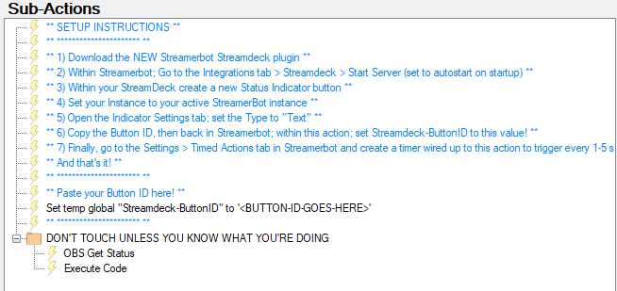

***Steps with screenshots on next page!***

1. Download the NEW StreamerBot Streamdeck extension if you haven’t already  
   <https://streamdeck.streamer.bot/>
2. In Streamerbot; Go to Integrations tab > Stream Deck > Start Server + set to autostart  
   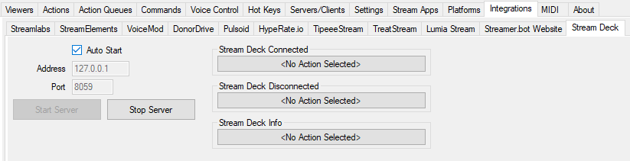
3. Within StreamDeck, create a new Status Indicator button  
   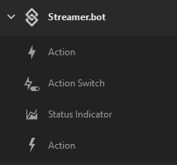
4. Set your Instance to your active StreamerBot instance  
   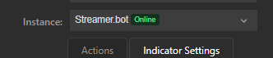
5. Open the Indicator Settings tab; set the Type to “Text” (you are welcome to change the text color here as well if you’d like)  
   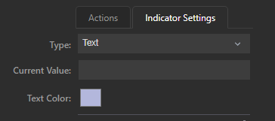
6. Copy the Button ID, then go back to StreamerBot, within the action we imported, set the StreamDeck-ButtonID to this value  
    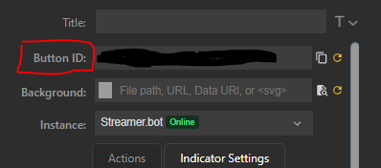
7. Finally! In StreamerBot, go to Settings > Timed Actions. Create a new Timed Action pointed to this action we just setup! Set it up just like mine, but feel free to set the timer duration to whatever you’d like! This is how often the button on your streamdeck will check for changes! You can set it to check every second, every 5 seconds, up to you! I set mine to every 3 seconds  
     
   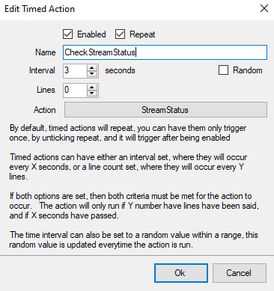

***And that’s it! Now when you go live, or hit record in OBS this button will change to tell you if you are live, with your FPS count and uptime!***

